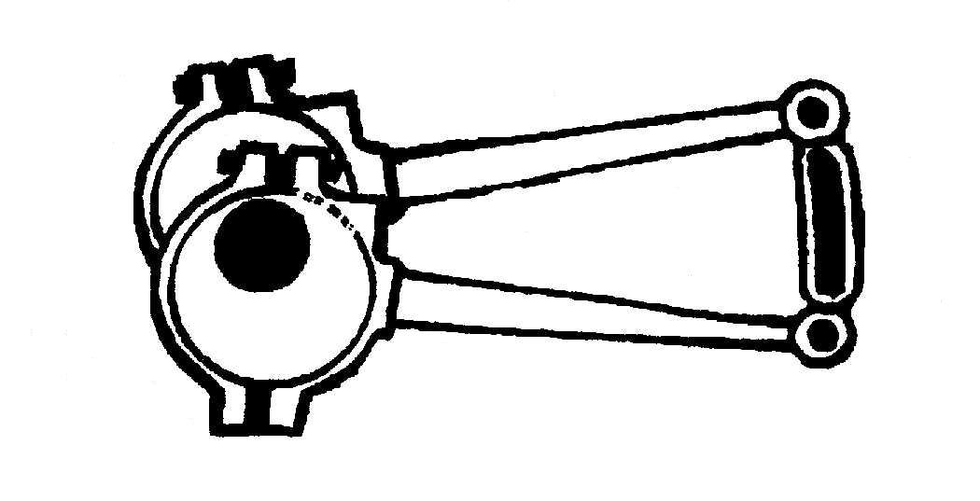
Chesterfield and District Model Engineering Society Limited
MEMBERSHIP APPLICATION FORM : 2020
The age group is vital for insurance purposes.
Please use block capitals :
16 to 64

65 or over
Name __________________________________________________ Age group
(please tick)
Address ________________________________________________

________________________________________________

________________________________________________ Post code _______________

Telephone ____________________________ Email ________________________________________

General areas of interest _______________________________________________________________

_______________________________________________________________

Models etc built or under construction _____________________________________________________

_______________________________________________________________

Membership of other similar societies ____________________________________________________

I hereby make application to join the Chesterfield and District Model Engineering Society Ltd.
I agree to aim to support its procedures and activities, both work and leisure, to the best of my ability.

Signature _______________________________________________ Date ____ / ____ / ____

Data Protection Statement The personal information (addresses, telephone and age details) which you provide on this application form will be made available to members of the Committee of the Society solely for administration and insurance purposes and will not be used by the Society for marketing purposes. By submitting this form you agree for this information to be held.

- Annual adult membership subscription is currently £40. *Partner and *Junior membership can be held but only as an addition to a full adult membership.
- *Partner membership is available at £5 per year. If required, enter partner’s name and age group
here : _____________________________ age group (16 – 64), (65 or over)
- *Junior membership (aged 12 – 20) is available at £5 per year. If required, enter junior member's name
here : _____________________________
- If you wish to have your quarterly Newsletter posted (rather than collect it), please tick this box
and include an extra £3.

It is a condition of membership that all applicants have seen and understood the operational rules of the Society when applying as new members or when renewing existing subscriptions. Your membership is accepted with these conditions and may be subject to review.

The booklet INFORMATION FOR MEMBERS will be issued to every new applicant. The website also has the text of the booklet : www.cdmes.co.uk

For office use only

Fees paid £____________ on (date ) ___/___/___ New database entry _________

MEMBERSHIP NUMBER M PARTNER MEMBERSHIP NUMBER PM

JUNIOR MEMBERSHIP NUMBER JM
Please turn over for postage details.
Insurance group
This form should be returned, together with the first subscription (plus partner and junior fee if applicable) to theTreasurer, Mr Dennis Wharmby at a club meeting or by post to

Mr D Wharmby, 10 Pondwell Drive, Brimington, CHESTERFIELD S43 1PH.

PLEASE enclose a stamped addressed envelope for reply.

Any cheques should be crossed and made payable to CDMES Ltd.
Application form page 2

CHECK LIST . . (to prevent return of your form!)

- age groups declared?
- cheque signed and dated?
- stamped-addressed envelope enclosed?

